

data Analysis and sales reccomendations

By Kamalpreet Kaur



**Table of Contents**

**Analysis Objective: -** 2

**Drilled downed objectives based on key metrics: -** 2

**EDA: -** 2

**Exploratory Data Analysis (EDA)** 2

**Visualizations and Key Metrics** 2

**Insights and Recommendations** 3

**Analysis Objective: -**

The main aim of this analysis is to provide actionable recommendations to Clipboard Health's sales leadership team. These recommendations focus on expanding contract-based staffing services, increasing revenue, and meeting nursing home staffing needs effectively.

## **Drilled down objectives based on key metrics: -**

1. Substitute cost-effective and quality contract-based staff for employee-based staff to boost revenue across all states.
2. Provide additional staff on the busiest days of the week for nursing home providers.
3. Address staffing requirements for Registered Nurses (RNs), Licensed Practical Nurses (LPNs), and Certified Nursing Assistants (CNAs) across all providers.

# **EDA: -**

## **Exploratory Data Analysis (EDA)**

**Tools Used:**

* **Excel:** Initial data exploration, cleaning, and preparation.
* **Power BI:** Advanced analysis and visualization to uncover trends and actionable insights.

**Process in Excel:**

1. Explored column names, meanings, and removed irrelevant columns.
2. Cleaned the dataset by handling null values, correcting data types, and removing duplicates.
3. Standardized the date column and filtered errors.

**Power BI Analysis Steps:**

1. Created calculated measures using **DAX** for total contract and employee hours by summing all staff types' data.
2. Added a “Day of the Week” column to analyze trends using **weekday** and **switch** functions.
3. Retrieved mandatory staff hours per resident from **CMS guidelines** to compute and add required hours columns for CNAs, RNs, and LPNs.
4. Summed up total required hours for each staff type using **MDS census data.**

## **Visualizations and Key Metrics**

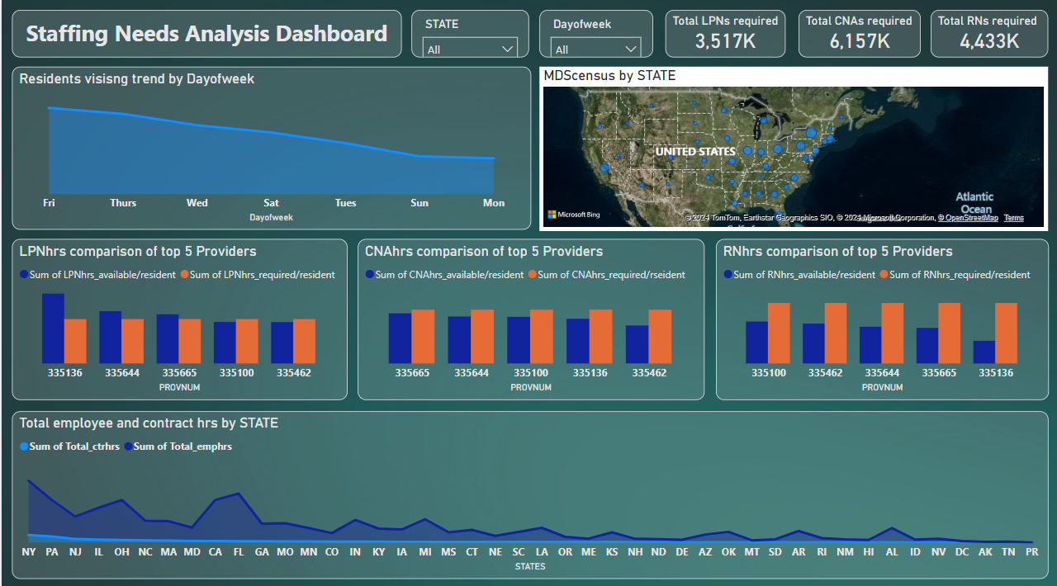

**1. Area Chart:** Comparison of total contract and employee hours across states.

* Reveals stark differences, with contract hours lagging 25–35 times behind employee hours in states like Florida (FL) and California (CA).

**2. Area Chart:** Resident visiting trends across the week.

* Peak resident census occurs on **Fridays**, with Thursdays and Wednesdays also experiencing high activity.

**3. Column Charts:** Required vs. Available hours for CNAs, RNs, and LPNs for the **top 5 providers** by provider number (Provnum).

* Highlights staffing gaps, with CNAs requirement at 6,157, RNs at 4,433, and LPNs 3,517 thousand in all provider units.

**4. Map Visualization:** Geographic distribution of MDS census data to identify states with maximum and minimum resident needs.

**5. Cards:** Key metrics summarizing the total number of required CNAs, RNs, and LPNs in thousands.

# **Insights and Recommendations**

**Insights**

1. **Contract Hours Gap:**
   * Across all states, contract hours are significantly underutilized compared to employee hours.
   * High-potential states like FL and CA show maximum gaps in contract hour usage.
2. **Peak Workload Days:**
   * Resident census trends indicate higher staffing needs on Fridays, followed by Thursdays and Wednesdays.
3. **Top Providers Staffing Deficit:**
   * Even for the top 5 providers, there is a substantial shortfall between required and available staff hours, particularly for CNAs.

**Recommendations**

1. **Expand Contract Services:**
   * Promote contract-based staffing as a cost-effective alternative in states like FL and CA to address the gap and enhance revenue.
2. **Focus on Busy Days:**
   * Offer custom staffing solutions tailored to high-demand days (Fridays, Thursdays, and Wednesdays).
   * Design flexible staffing packages to meet peak weekly workloads.
3. **Address CNA Shortages:**
   * Invest in recruiting and onboarding more CNAs or ramp up contractor availability to fill the most critical staffing gaps.
4. **State-Specific Strategies:**
   * Develop marketing campaigns for underperforming regions, emphasizing the benefits of contract staffing for nursing homes struggling with employee shortages.
5. **Data-Driven Custom Solutions:**
   * Utilize PBJ data insights to offer personalized staffing recommendations to providers, ensuring Clipboard Health is the go-to partner for their staffing needs.

# **Monetary Benefit to the organization: -**

Substituting the employee staff with contract staff in all states where the gap is more, there will be the possibility of work for 35428006 thousand new staff members for other staff types except CNAs, RNs & LPN and thus more commission from these extra workers.

By fulfilling the staffing gaps, with 6,157 CNAs, 4,433 RNs, and 3,517 LPNs, the increase in revenue of these three types will be $4,06,186 which, in turn, can increase the commission of Clipboard Health organization also.

**_ _ _ _ _**